**Visvesvaraya Technological University, Belagavi**

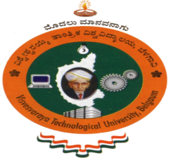

## **MINI-PROJECT REPORT**

## **on**

### “ONLINE BUS TICKET BOOKING”

**Submitted in the partial fulfillment of requirements for the completion of**

**MASTER OF COMPUTER APPLICATIONS (MCA)**

Submitted By

**ASHWITH MARIA DSOUZA 4VP21MC004**

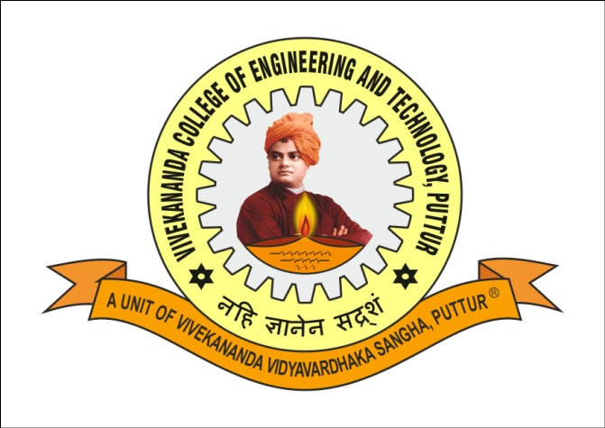

**DEPARTMENT OF MASTER OF COMPUTER APPLICATIONS (MCA)**

**VIVEKANANDA COLLEGE OF ENGINEERING & TECHNOLOGY**

**NEHRU NAGARA, PUTTUR (D.K.) - 574 203**

**2021-22**